### A Little Round Trinket Box to Hold Your Treasures

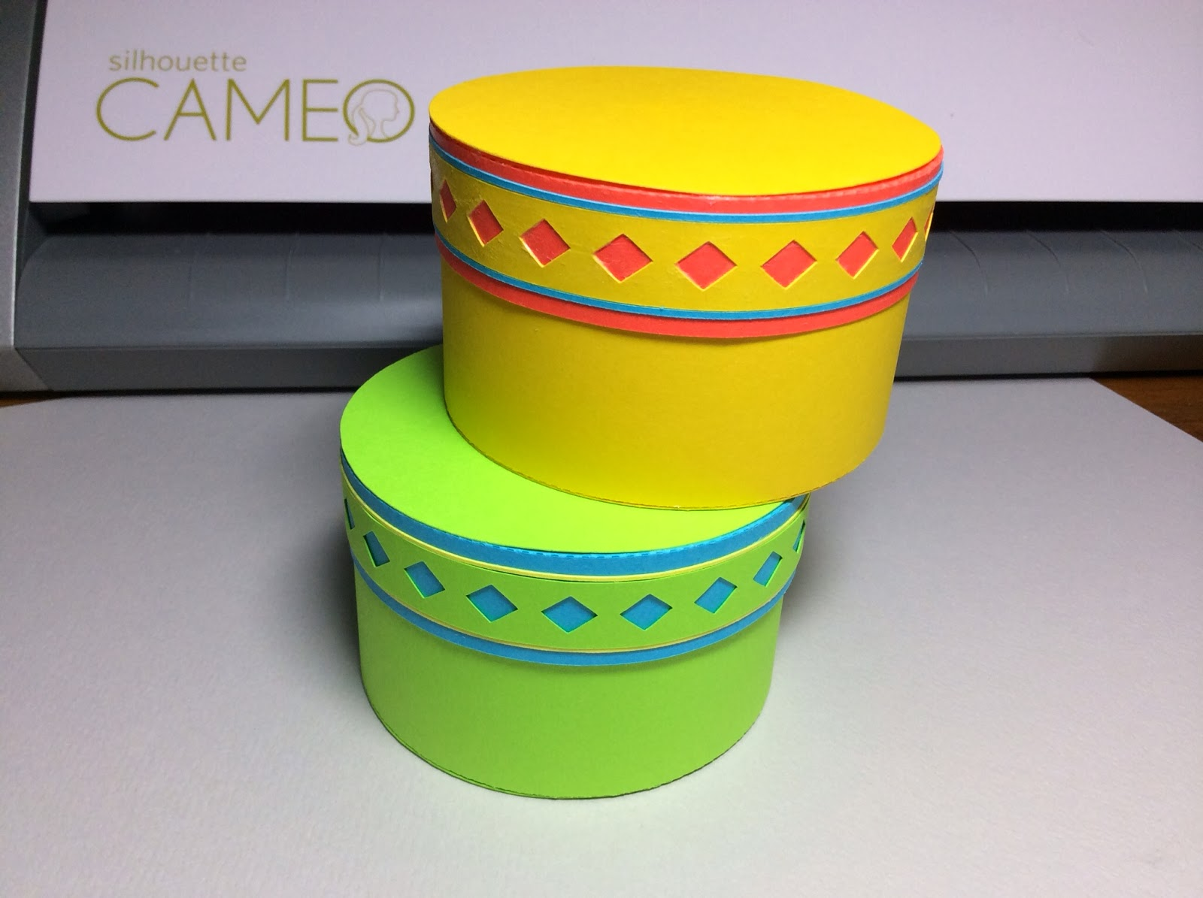

Pretty Little Trinket Boxes

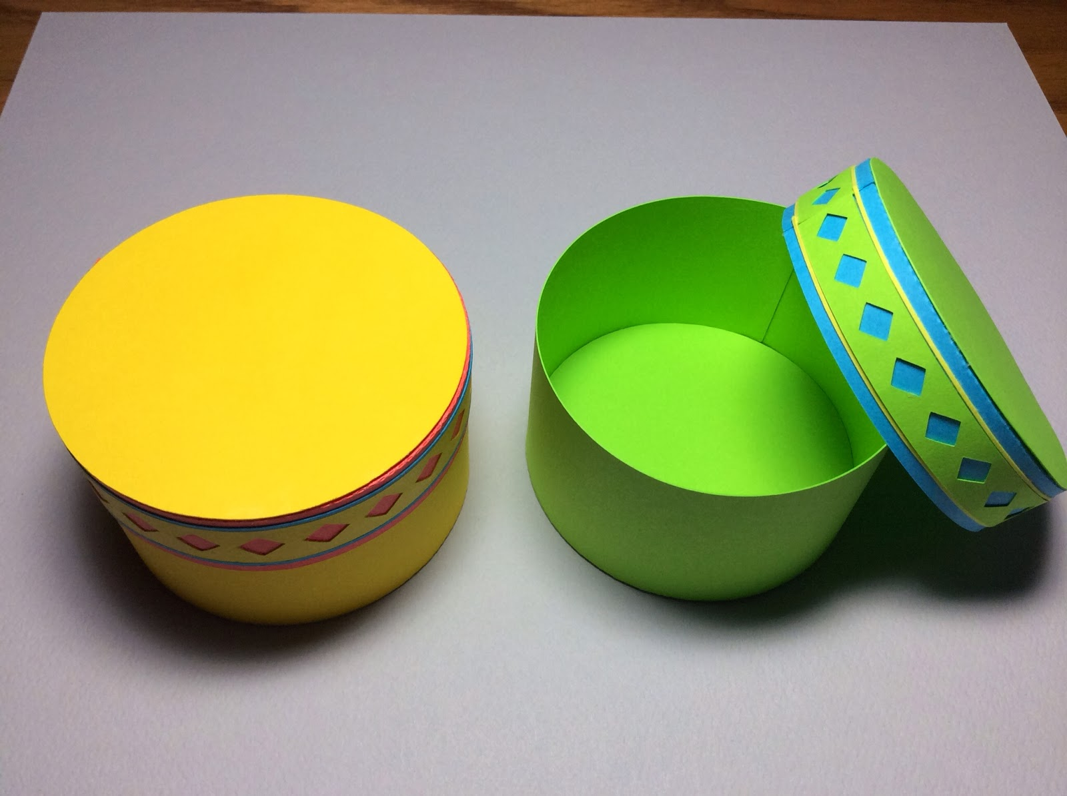

The Box is 2 inches deep and about 3 inches wide.

Here is a simple round box to hold your trinkets. I needed the pattern of this box for my next creation, a carousel box. Look for the post in a few days, as I have already completed the carousel but I wanted to post this simple round box first. I used math to create this shape. I needed to find the circumference of the top and the bottom of the box. Using the formula, Circumference of the Circle = 3.14 x Diameter of the Circle (The diameter is the length of a straight line going from side to side across the circle through the center point.), I found the lengths of the strips of paper which go around the sides of this box.

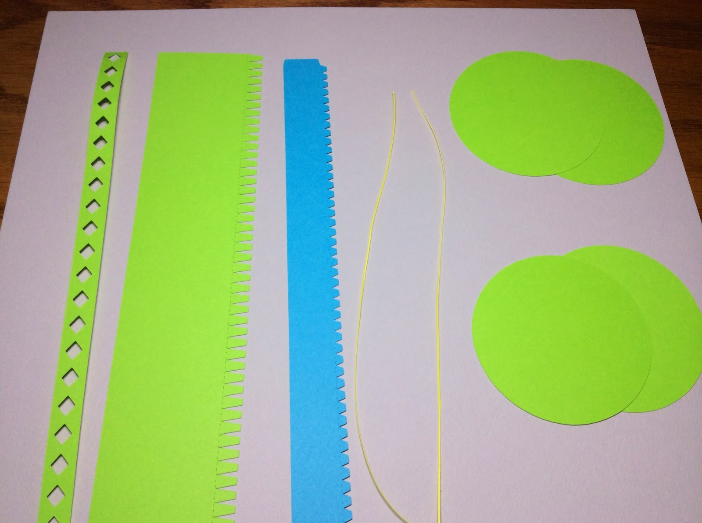

Layout the pattern pieces. Make sure to separate the two top circles and two bottom circles as the size of the two top circles are bigger.

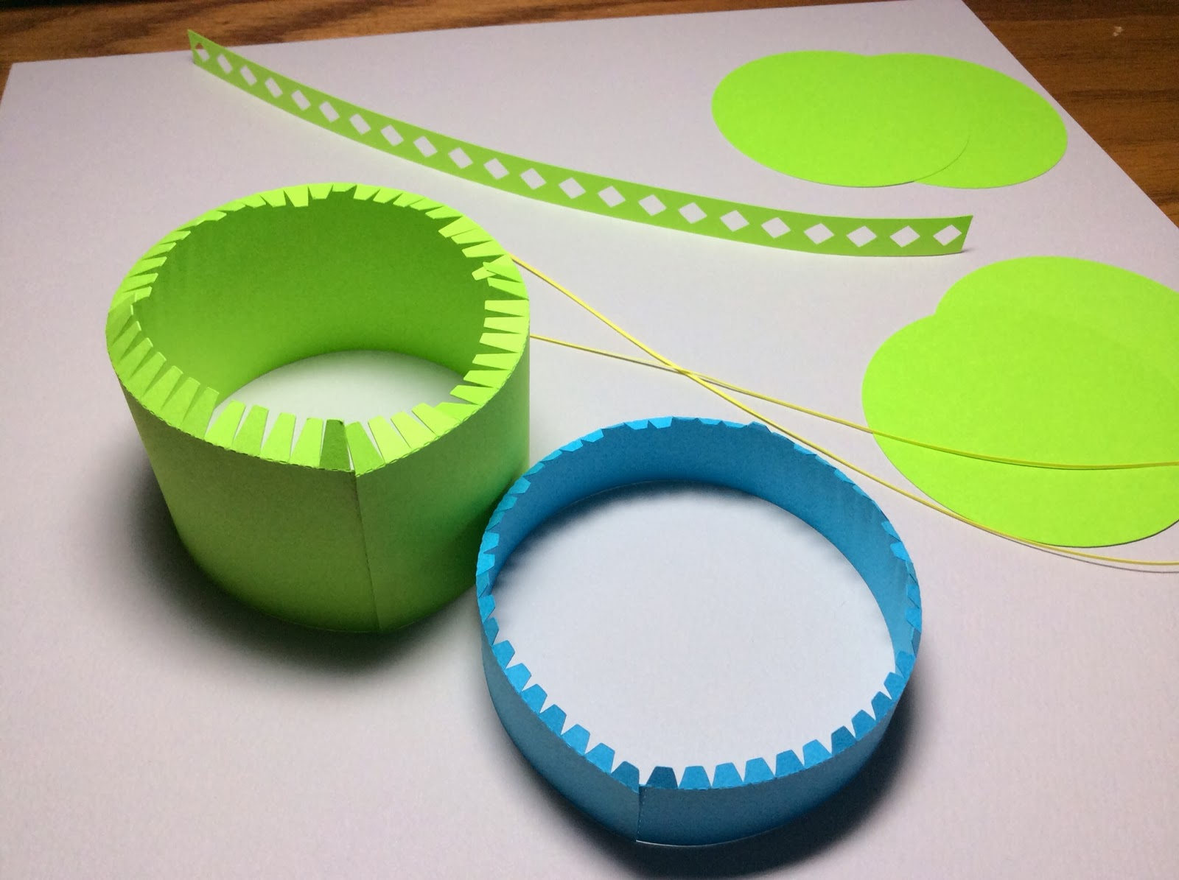

Glue the bottom(green) and top(blue) sides together. Bend the tabs at a right angle as shown.

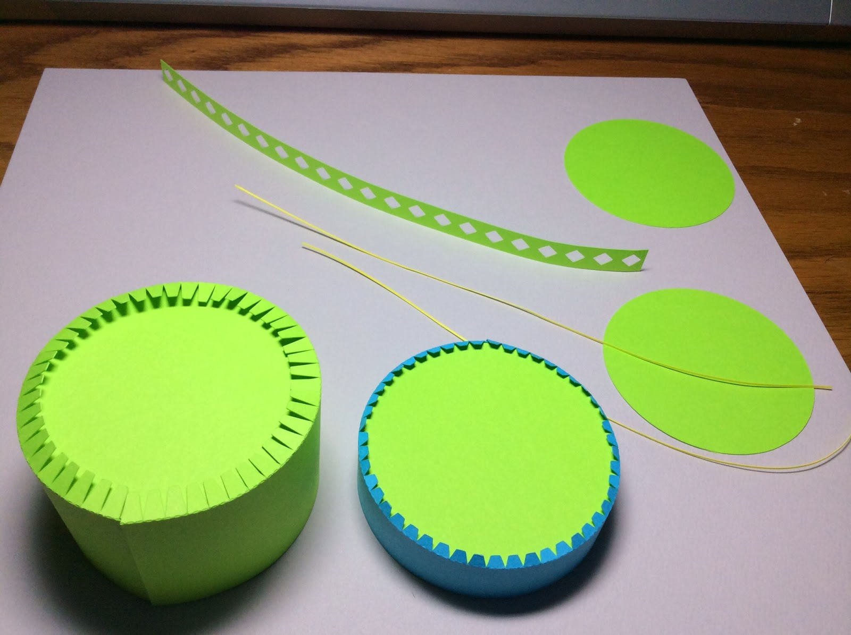

Glue the correct size circle to each piece.

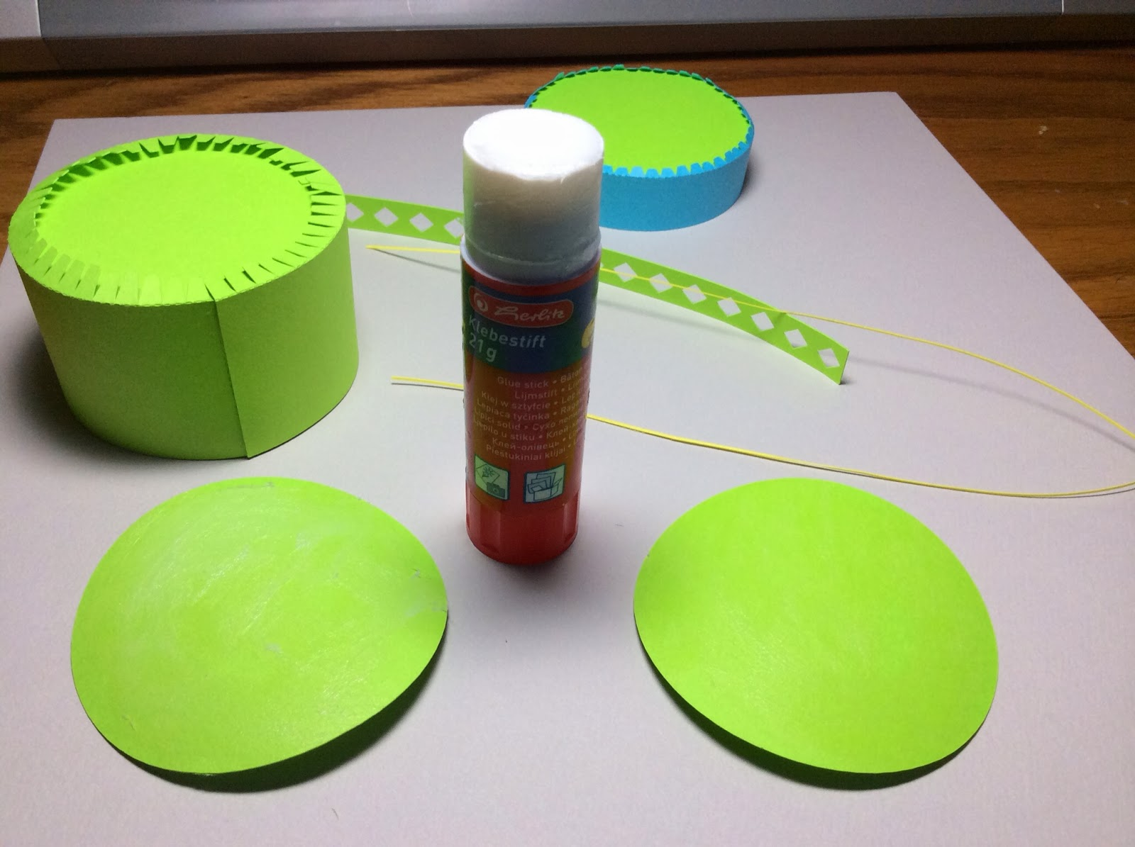

Put glue on each circle using a glue stick as the paper will not warp as much as other types of glue.

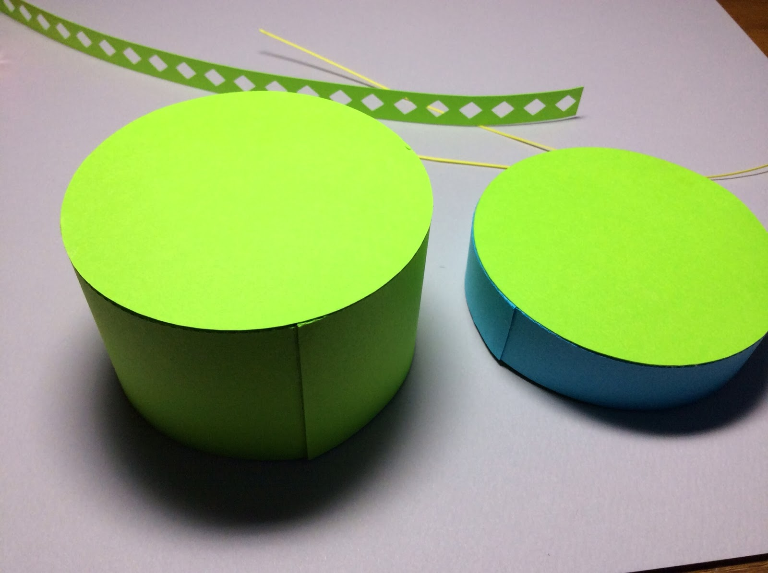

Attach to the correct circle to each piece.

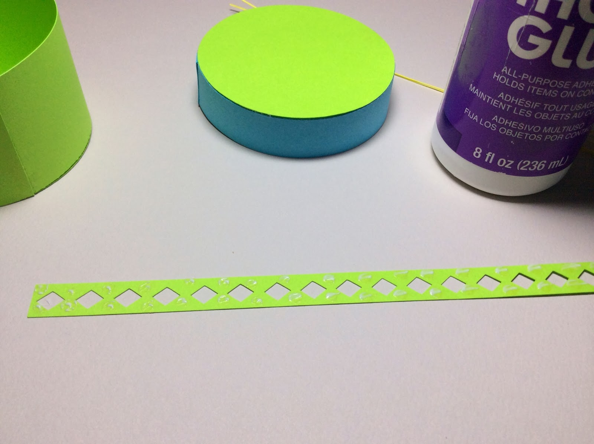

Add glue to the strip of paper as shown.

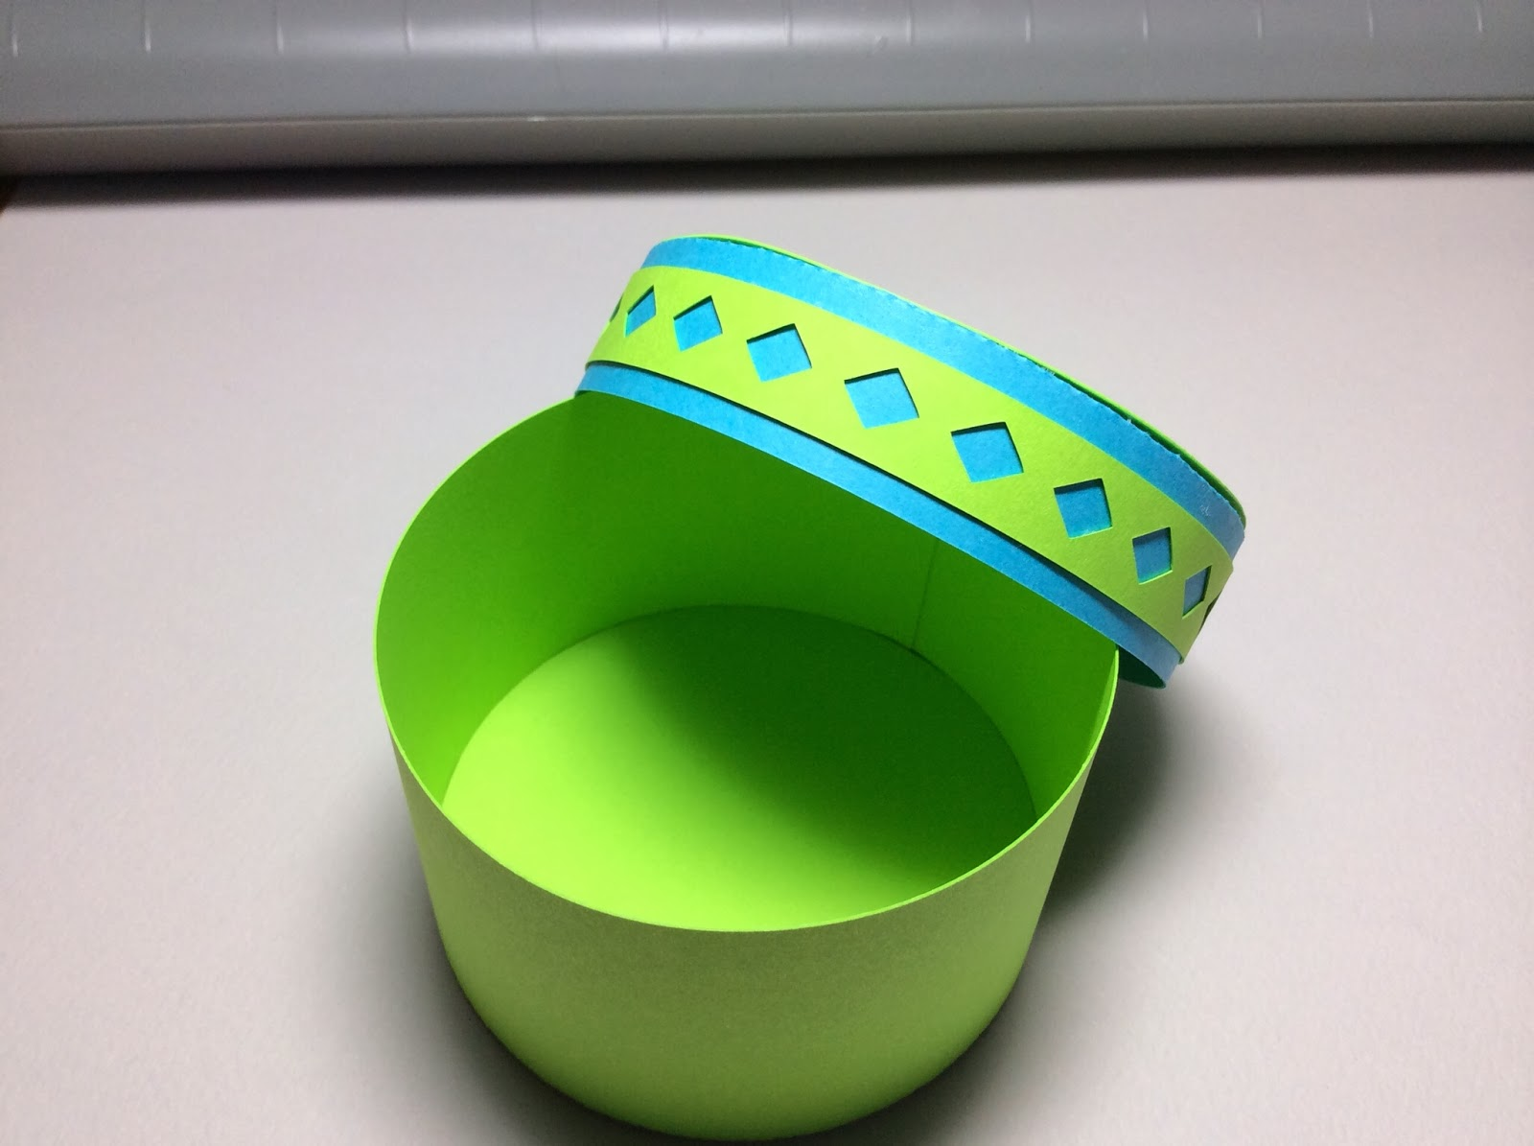

And attach it to the middle of the lid.

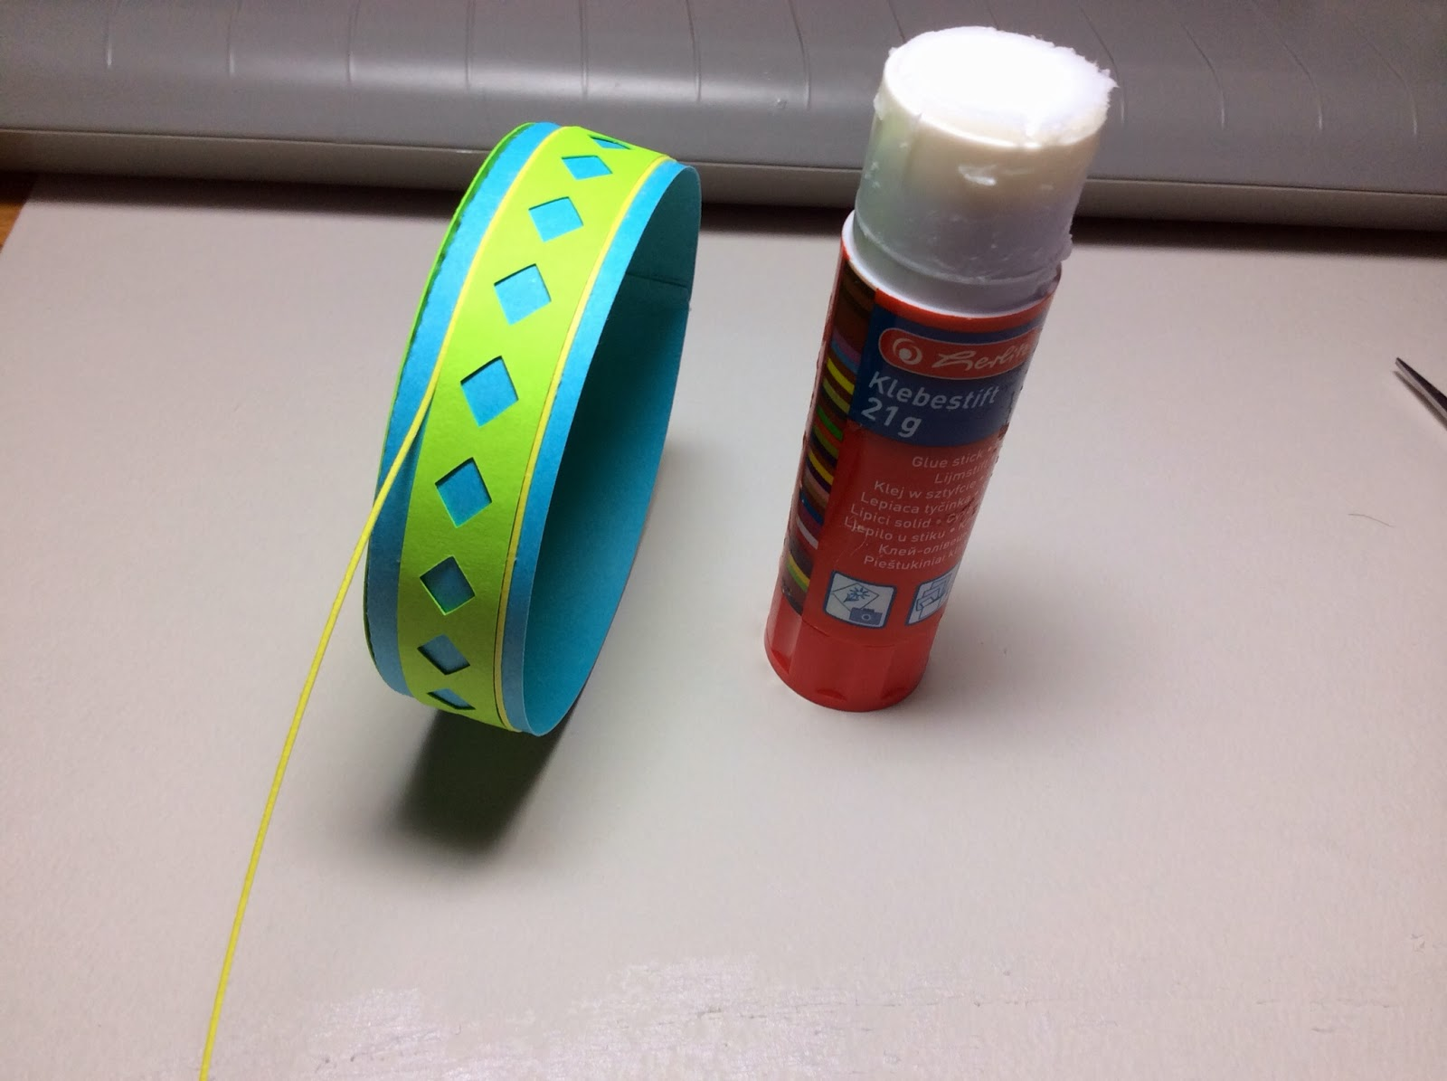

I added the glue to the paper before I attached it to the lid. I rolled the paper over the top of the glue stick to get glue on the paper.

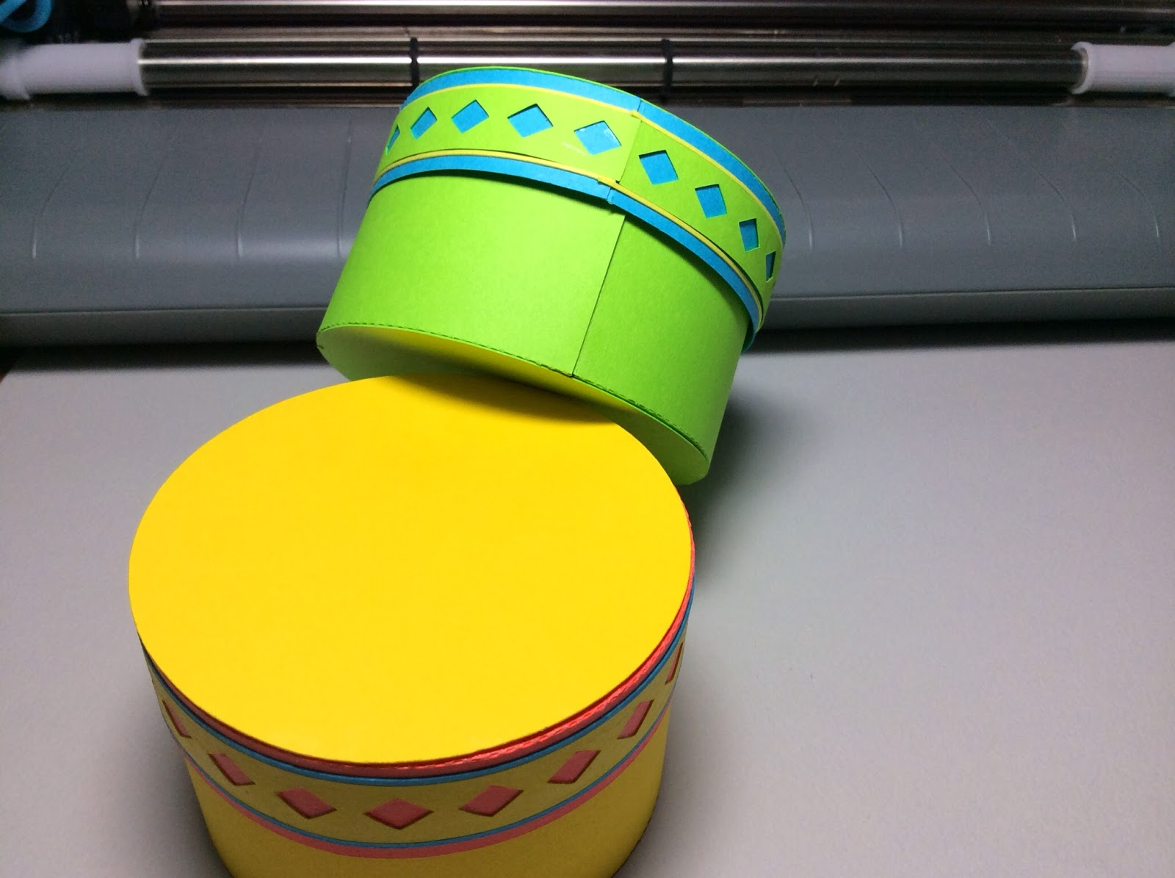

Here is what it looks like when completed.